The Git is a free and open-source distributed version control system designed to handle everything from small to very large projects with speed and efficiency.

Installation
Link for installation  https://git-scm.com/downloads | 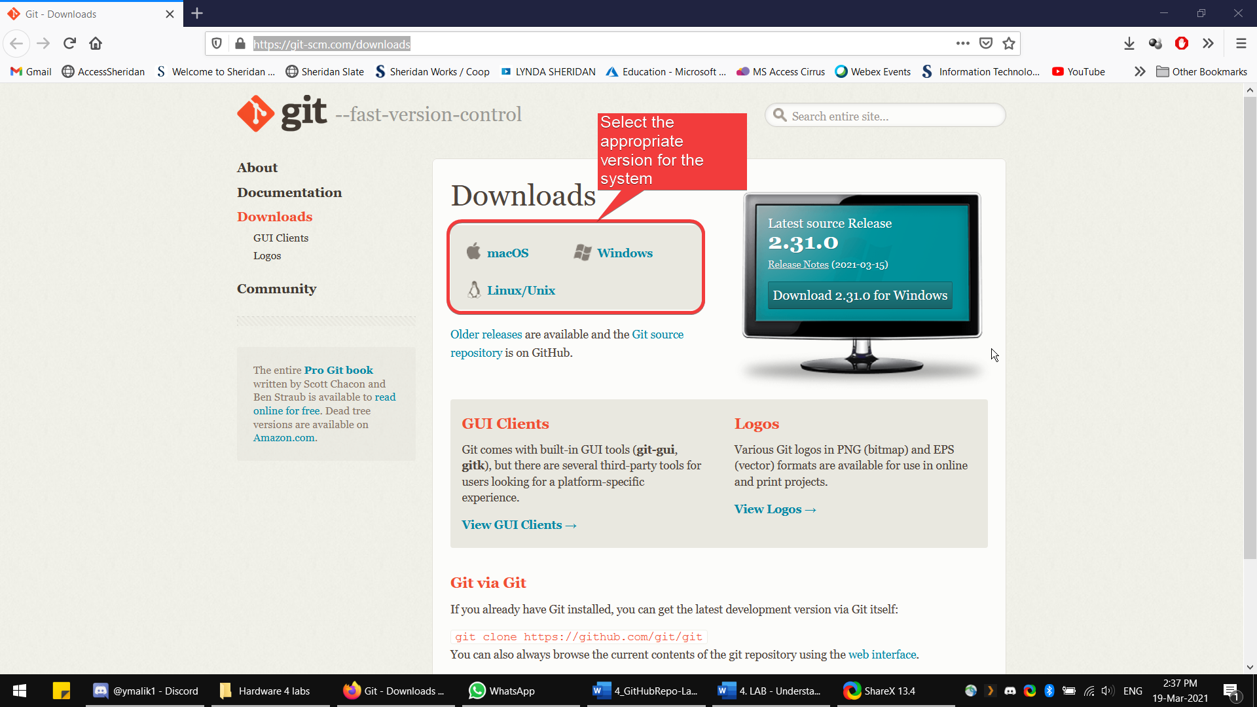
Install using the default settings. | 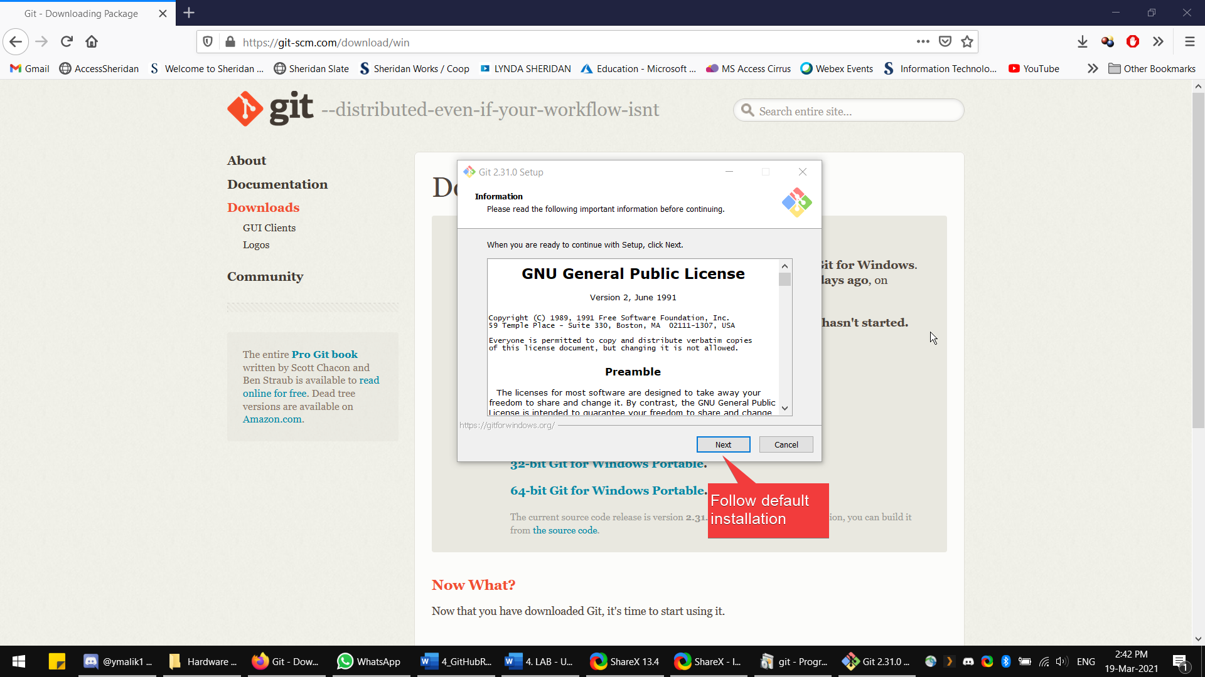
Select the default editor for the lab. Then continue pressing next as a default installation. | 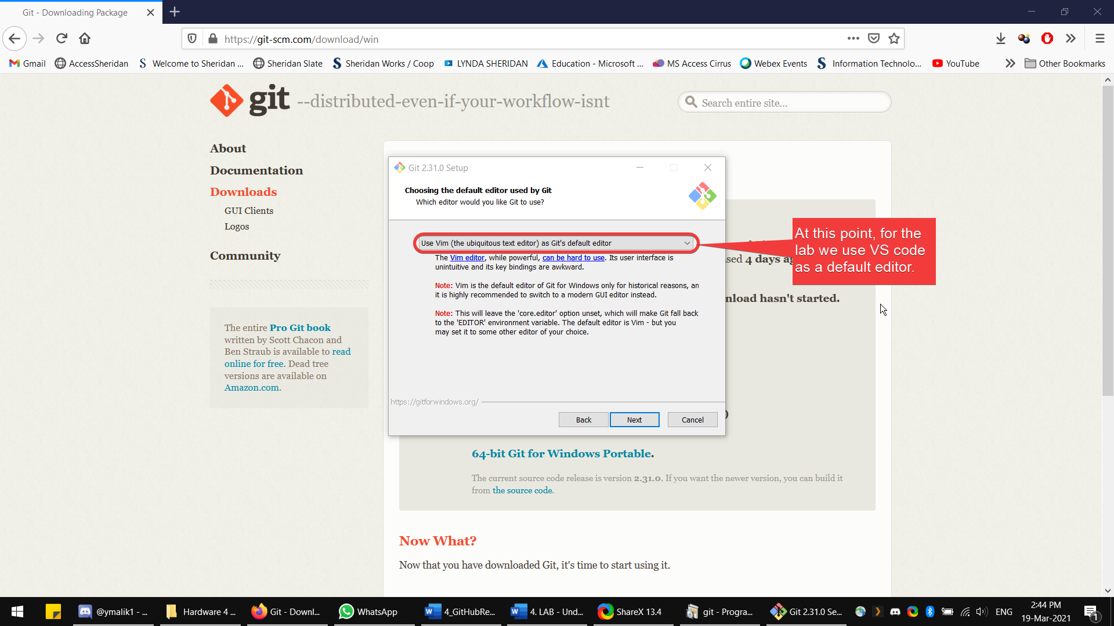
Click finish when it is done! | 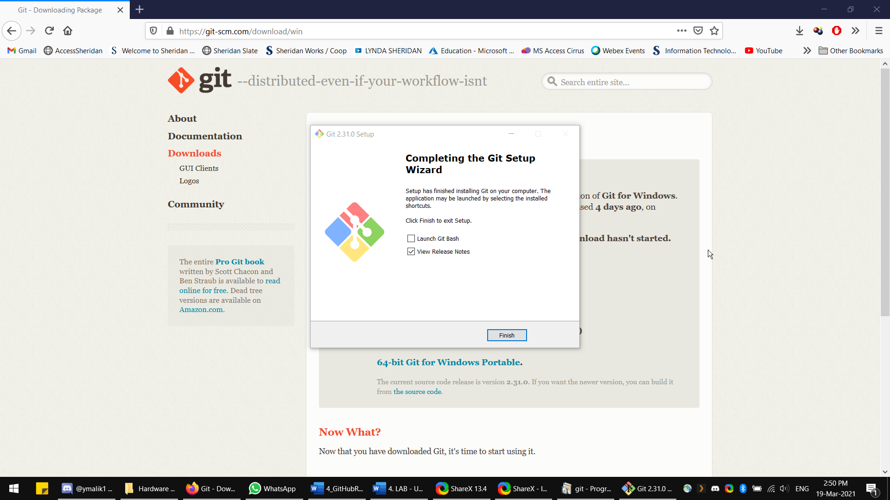

GitHub Repository
Repository: A directory or storage space where your projects can live. GitHub users shorten this to “repo.” It can be local to a folder on your computer, or it can be a storage space on GitHub or another online host. You can keep code files, text files, image files, you name it, inside a repository.
Creating an Account in GitHub  Link: https://github.com/ | 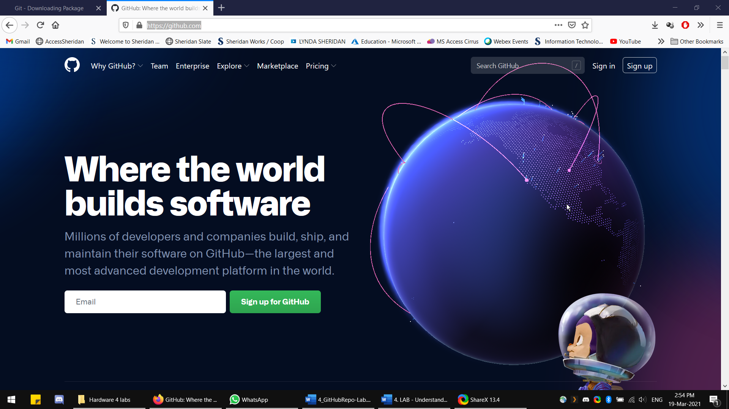
Sign-in, then on the upper right icon. Click your profile then select your repositories. | 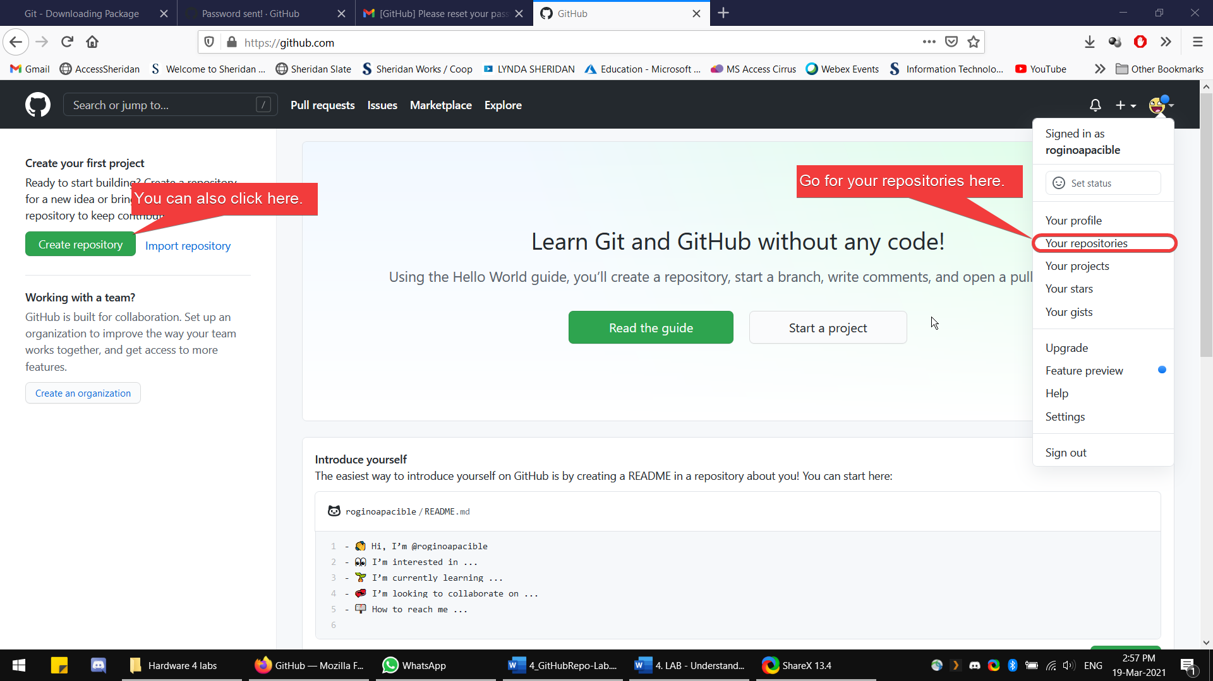
In this Page, click new. | 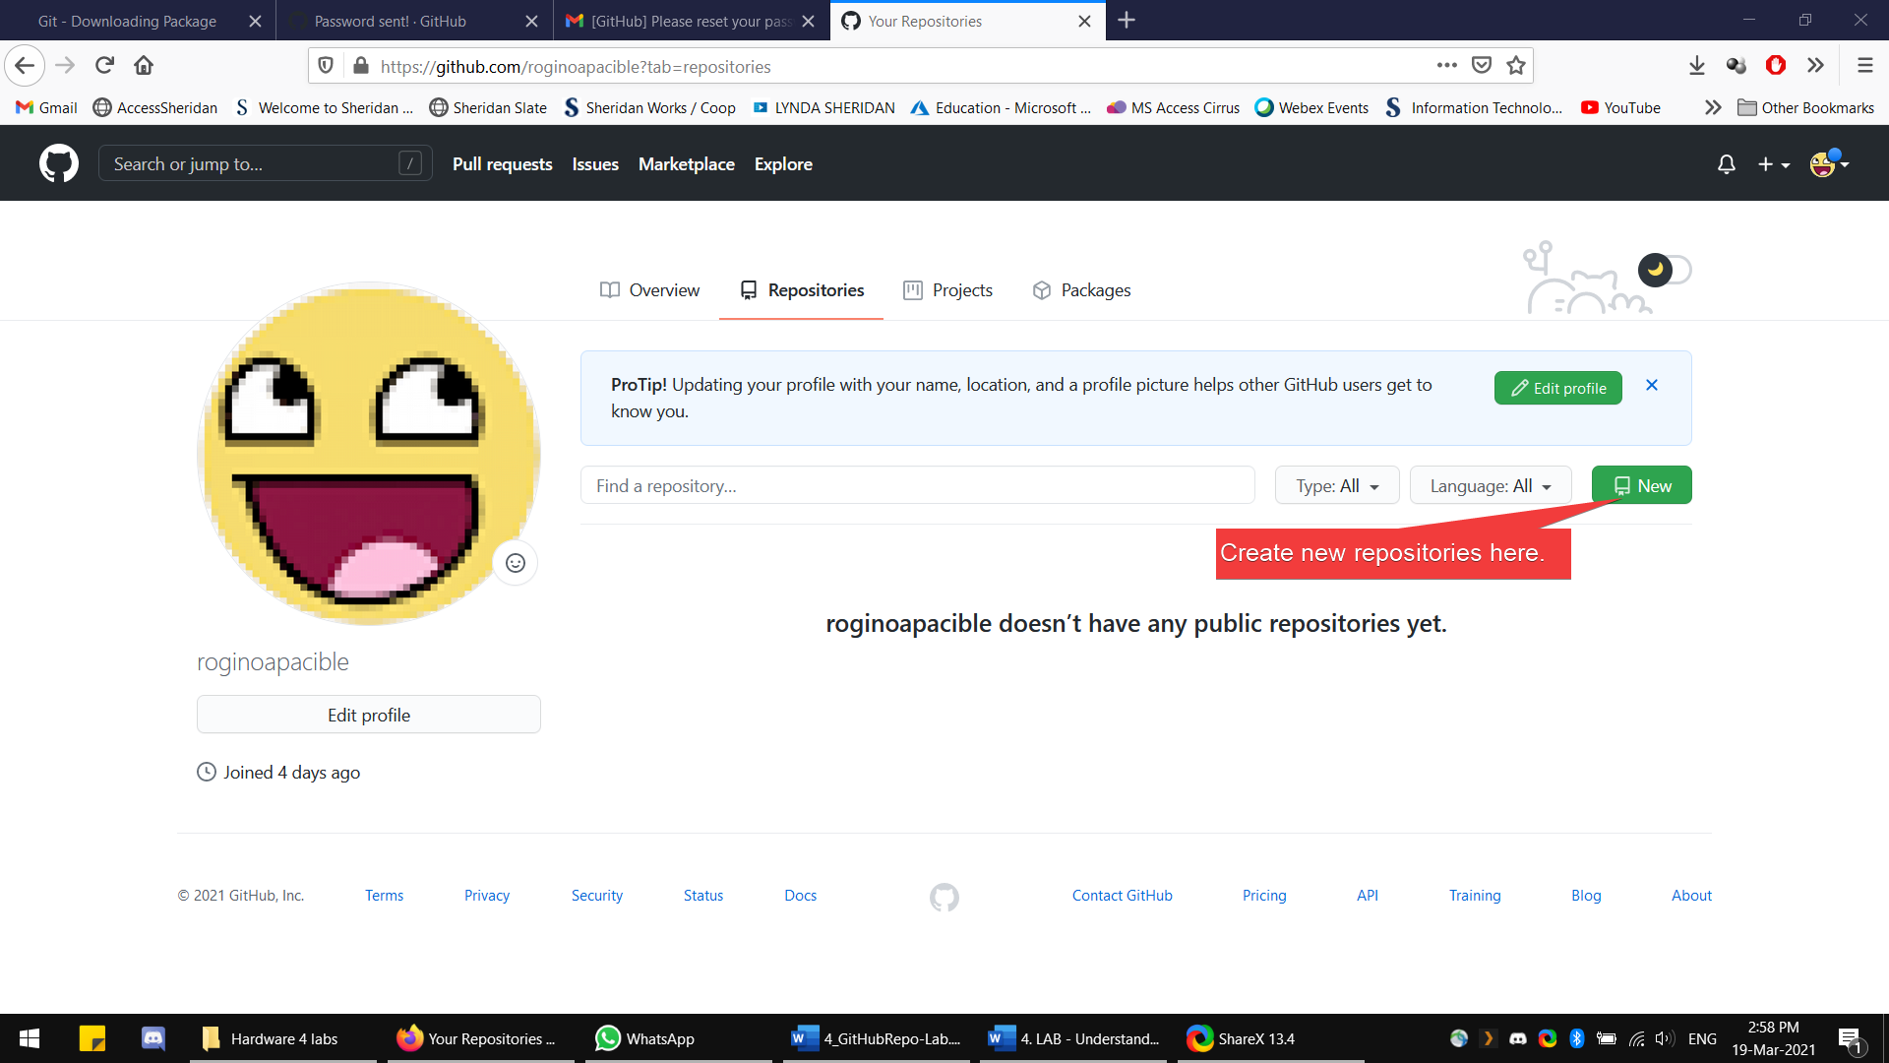
Page for creating a new repository. | 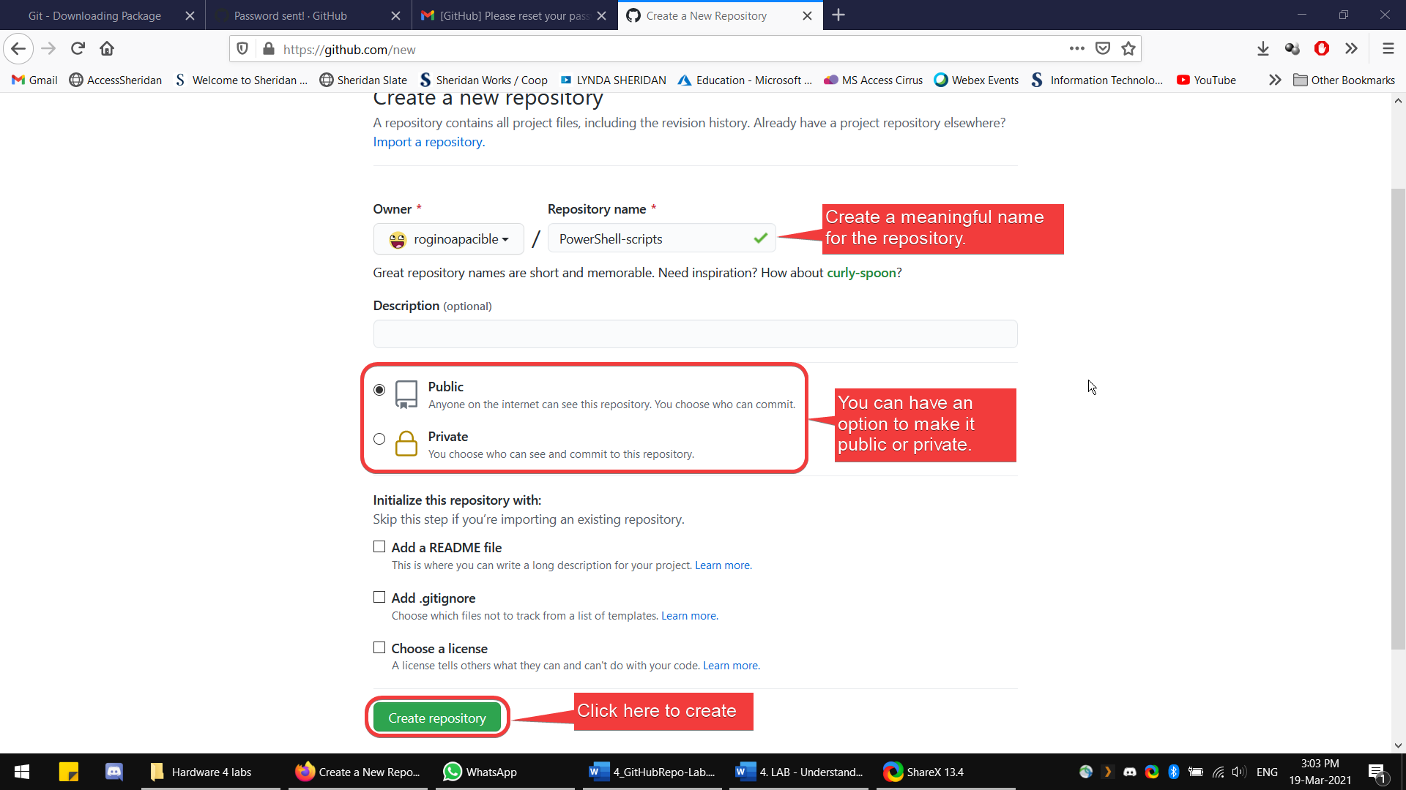
After creating, copy the link of your repository and then head on to VScode application. | 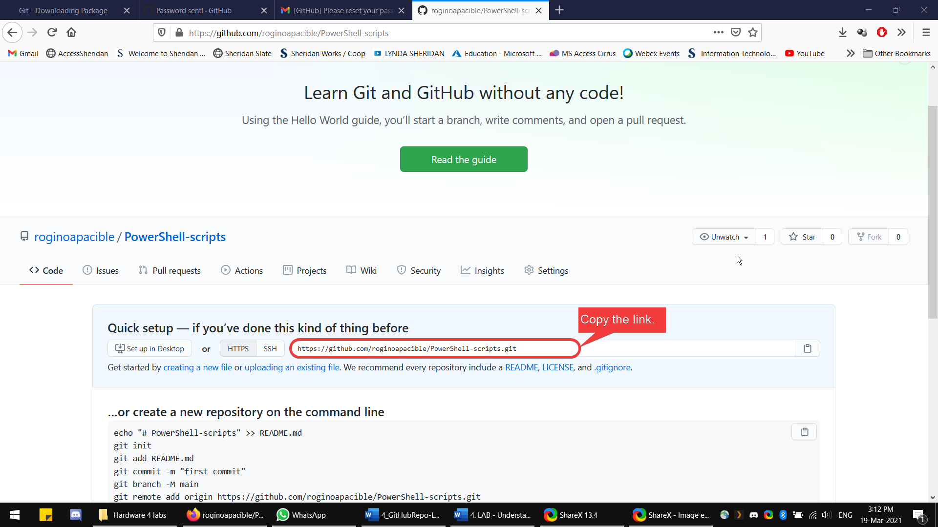

Setting up the Repo in VScode.
First set-up the user and email in a new terminal.  Command:  Git config --global user.name “name”  Git config --global user.email “email” | 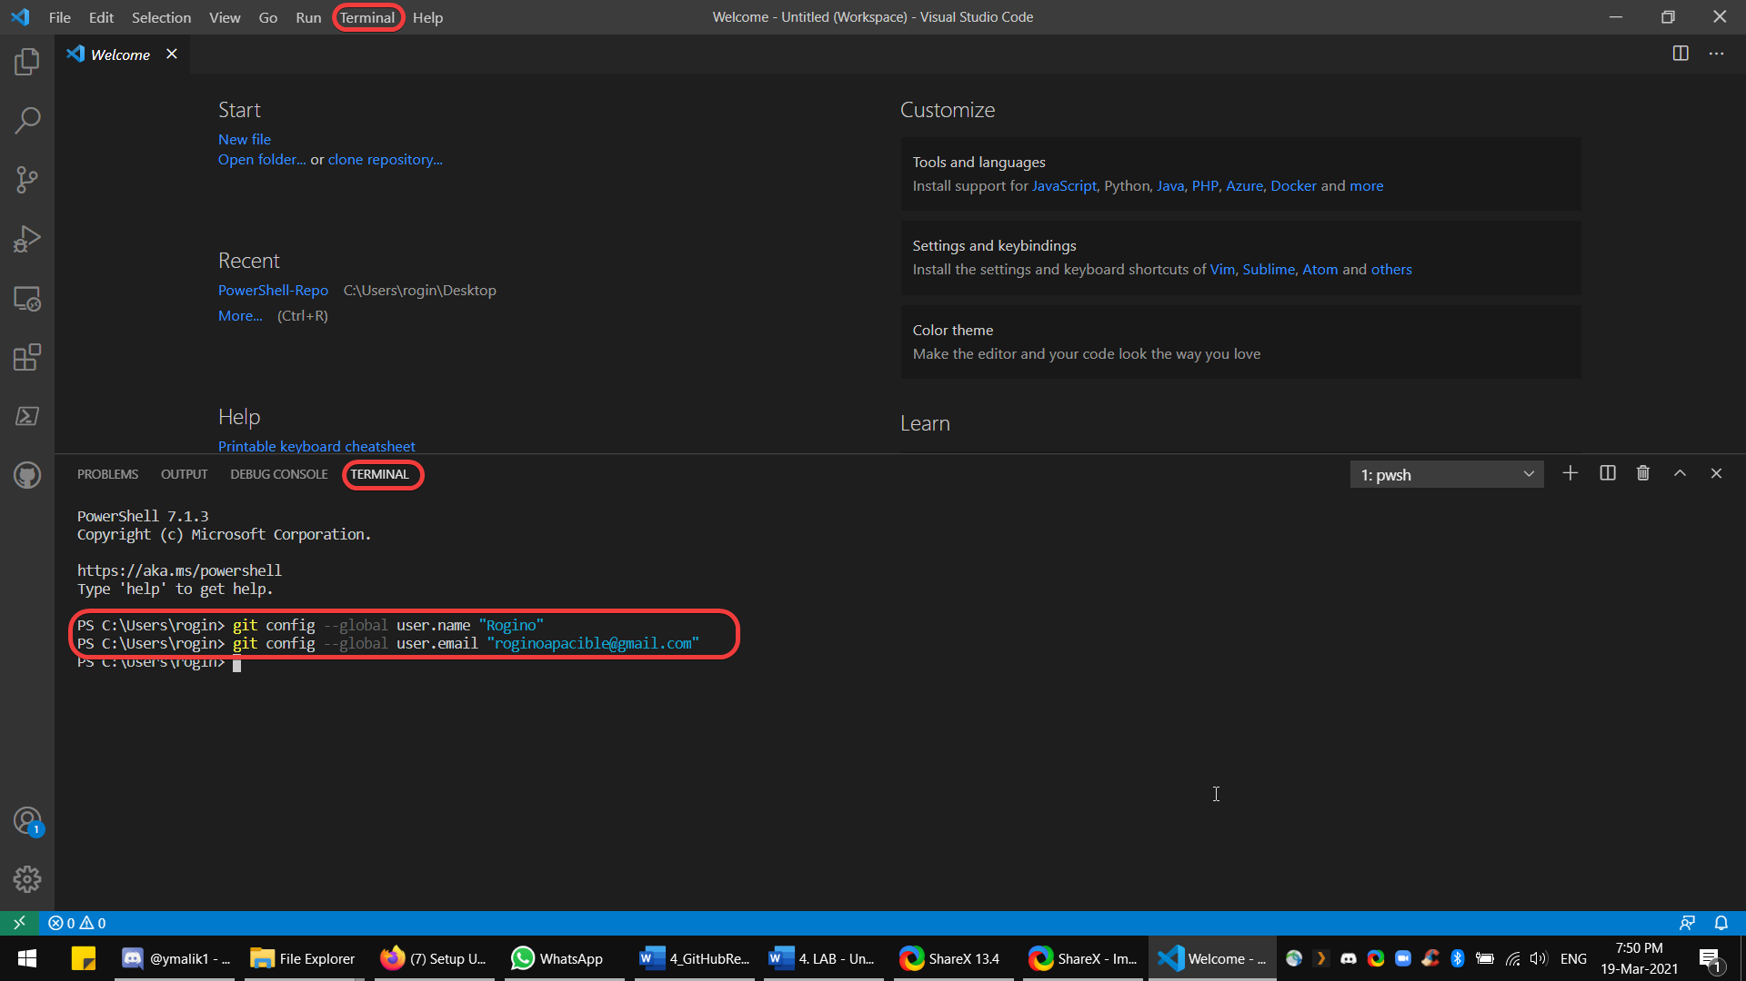
Next is add a new folder in the explorer tab.  This folder is where the script file.  And this folder is going to be the new repository to be added in github. | 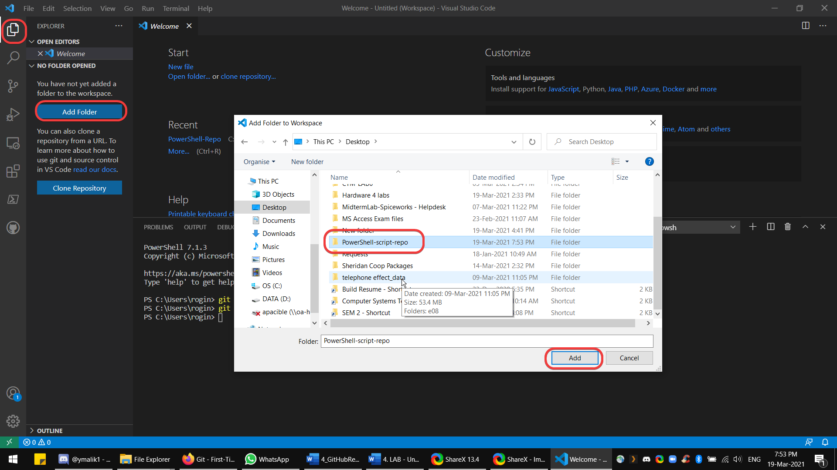
After adding the folder  You can see the files inside of it.  In this case, I can see that I saved my script file in this folder. | 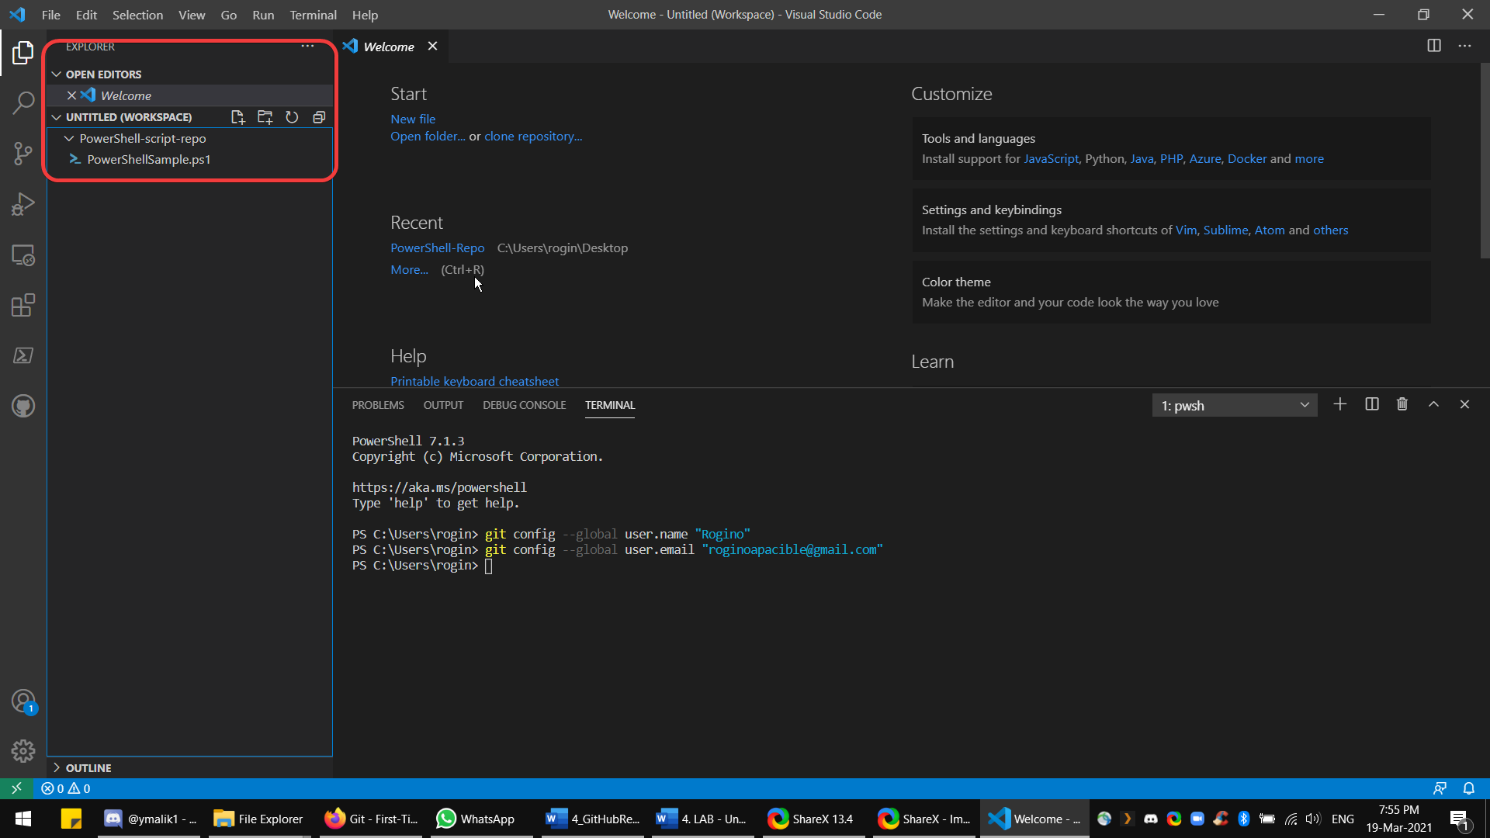
Then go to source control and Click initialize repository  Pick the workspace folder that has just added.  It will also display the recent on | 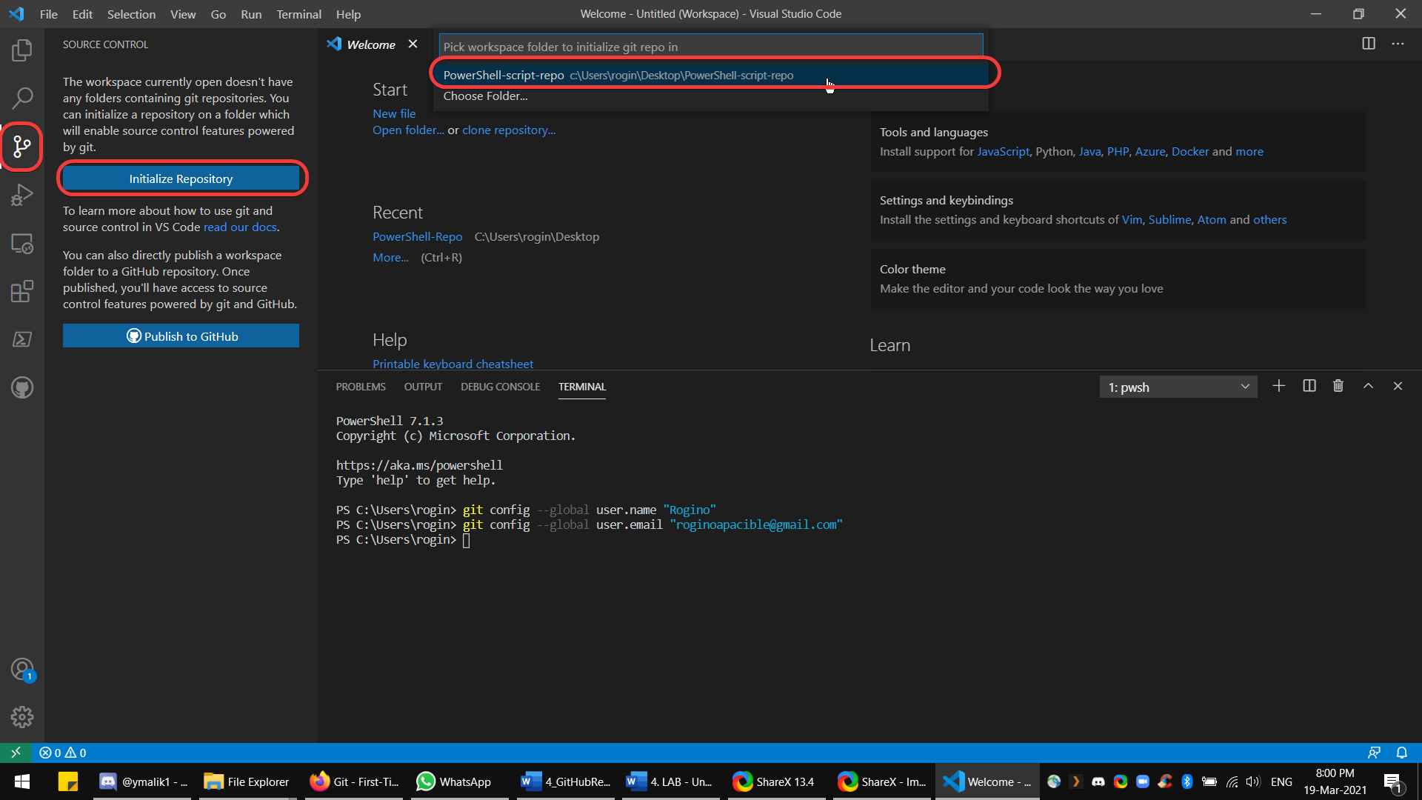
After the workspace has been added, the source control will update and will show the files. | 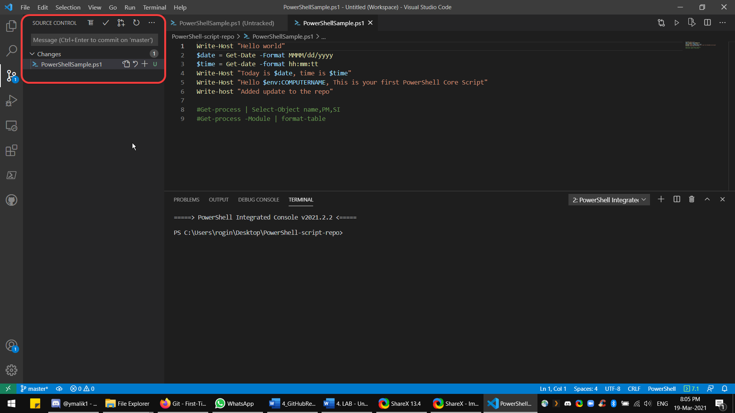
Do the first commit. | 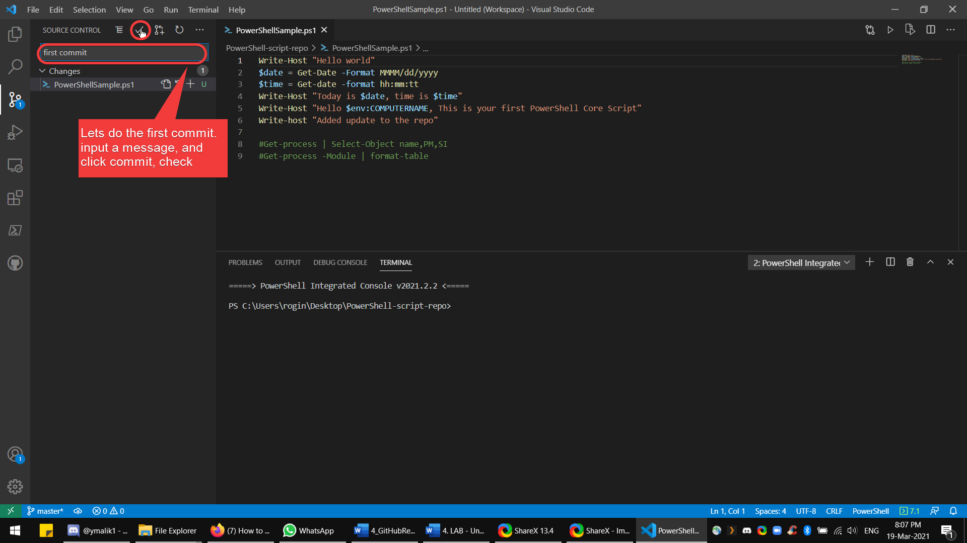
In this case, click yes. | 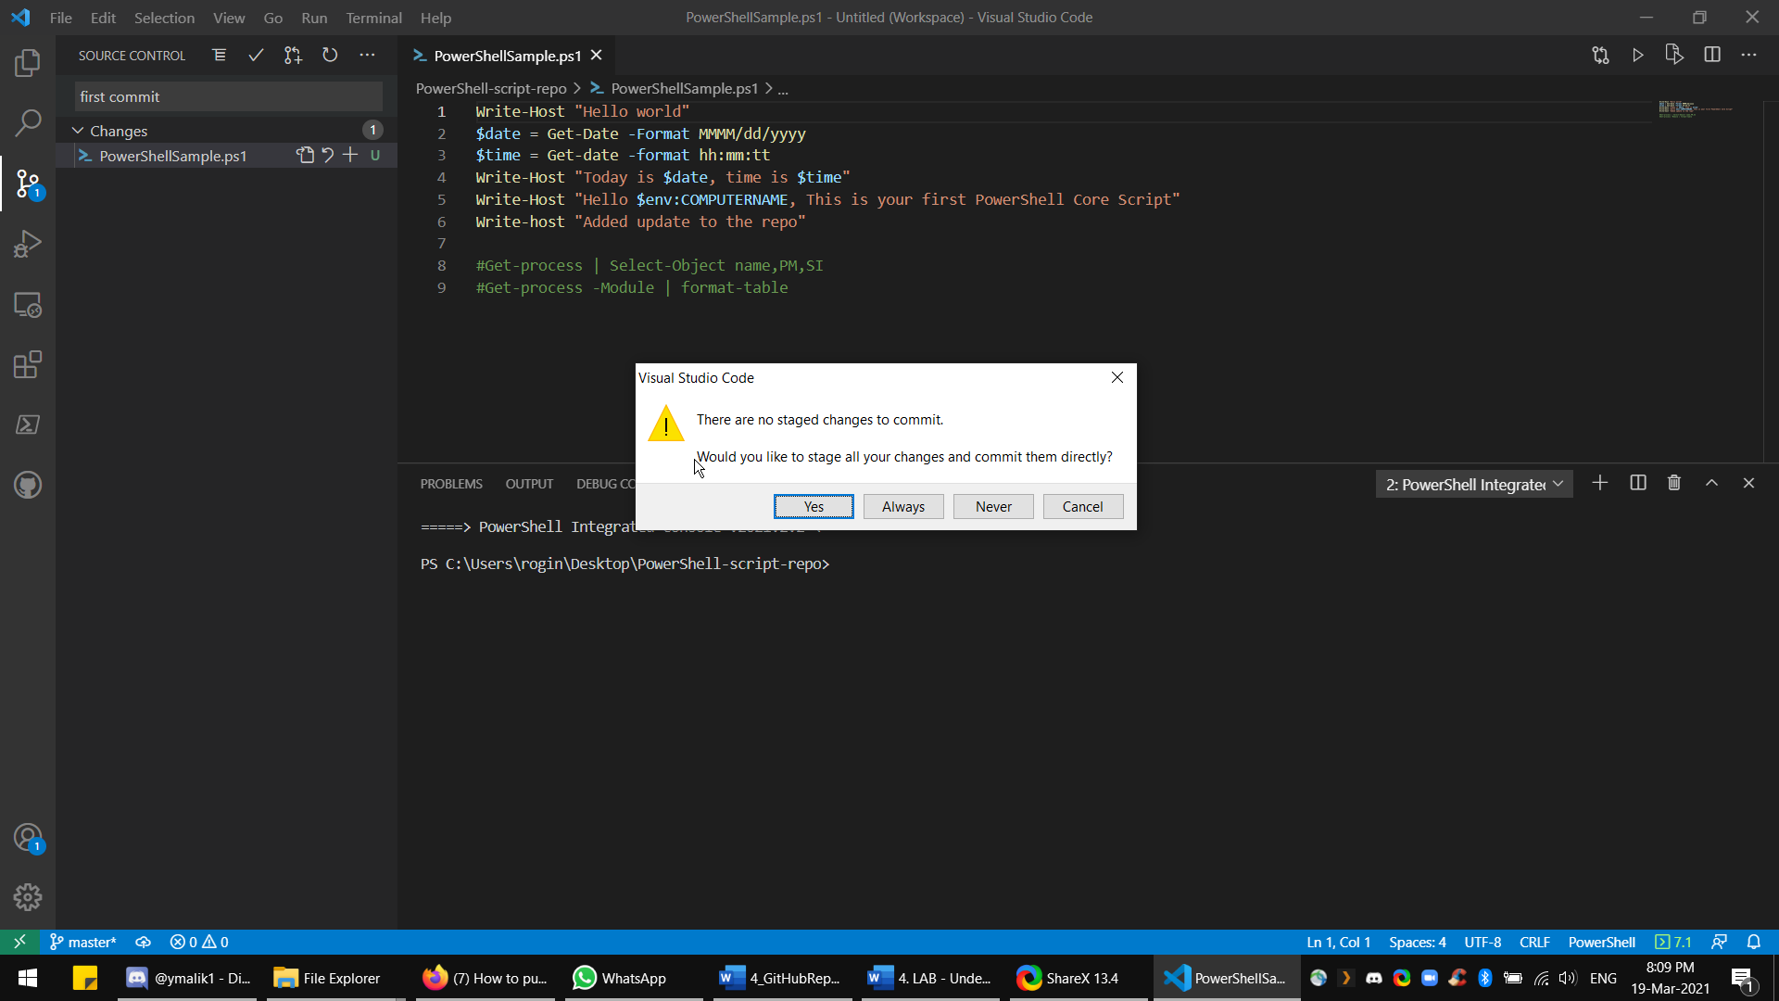
Then select push, on the option. | 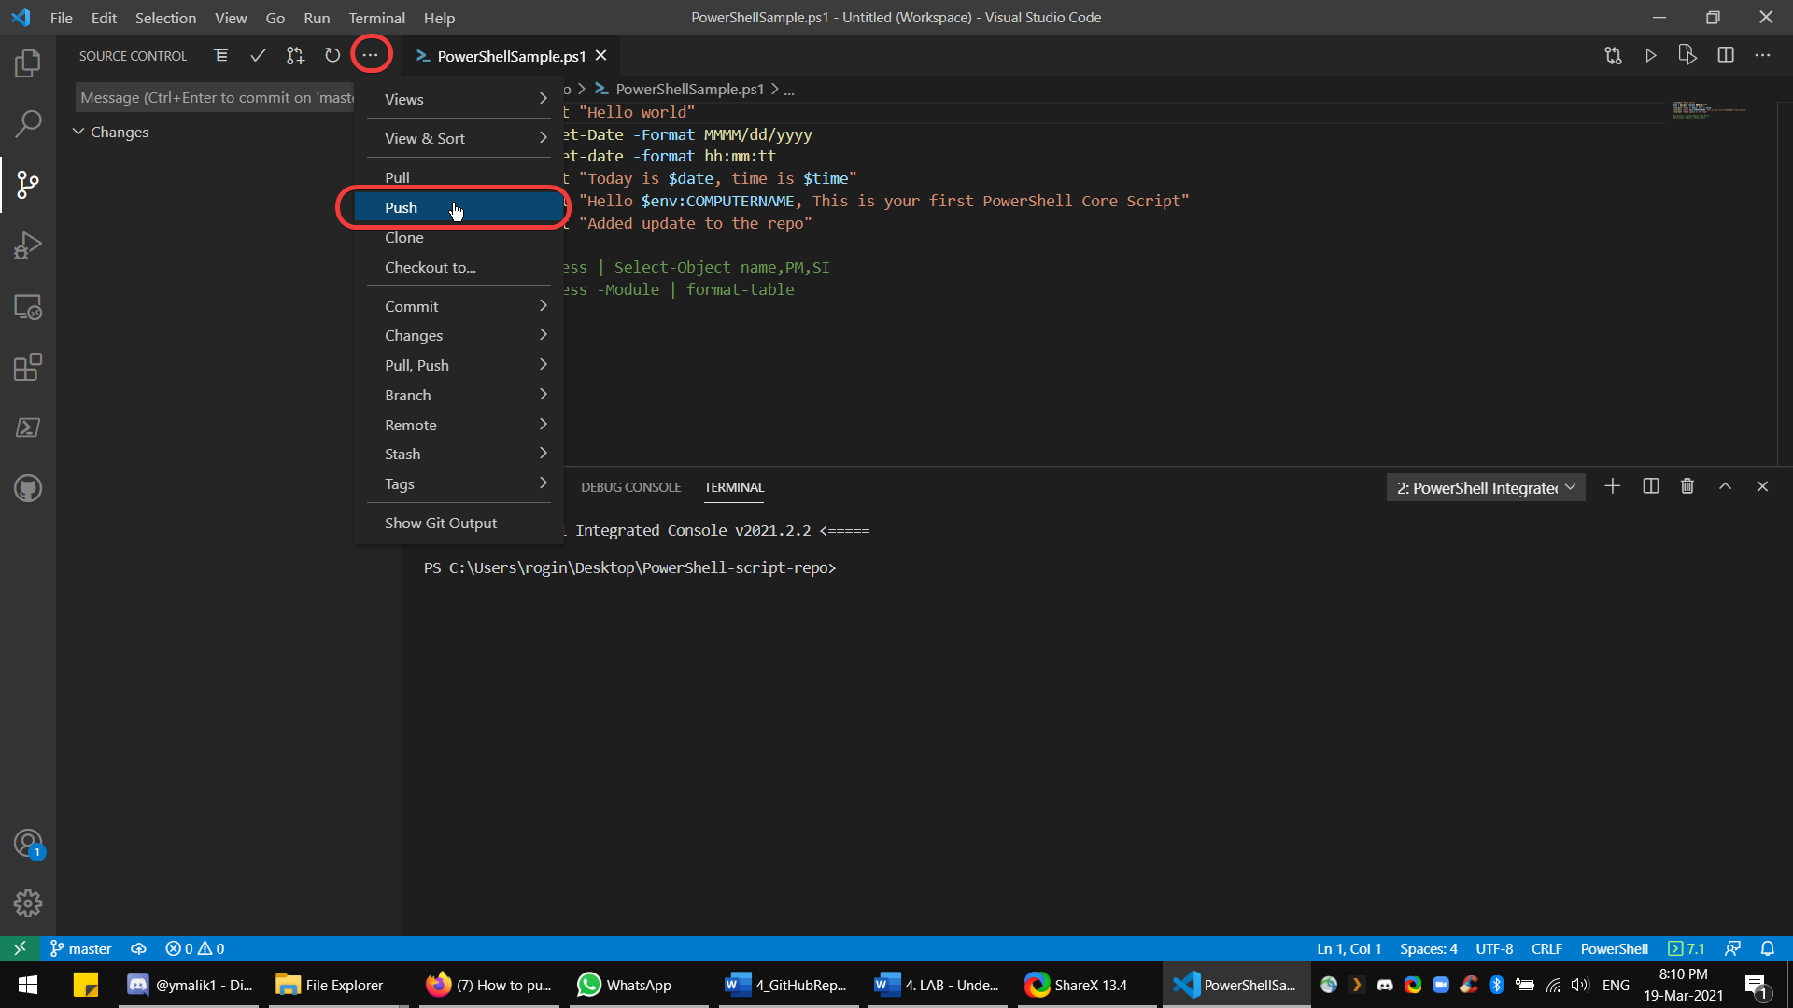
Then click add remote. | 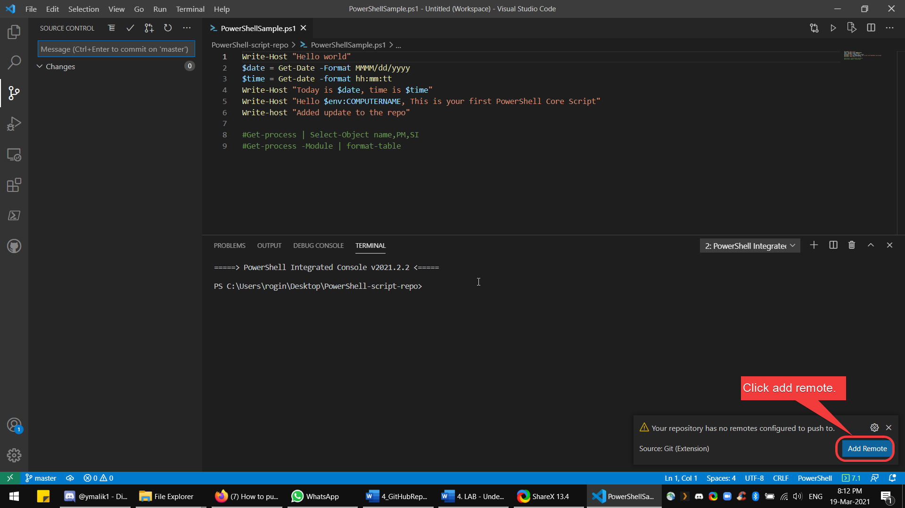
Paste the created link from GitHub.  This is the repository link.  Press Enter, then give it a Remote name.  It can be a name or whatever that is meaningful. | 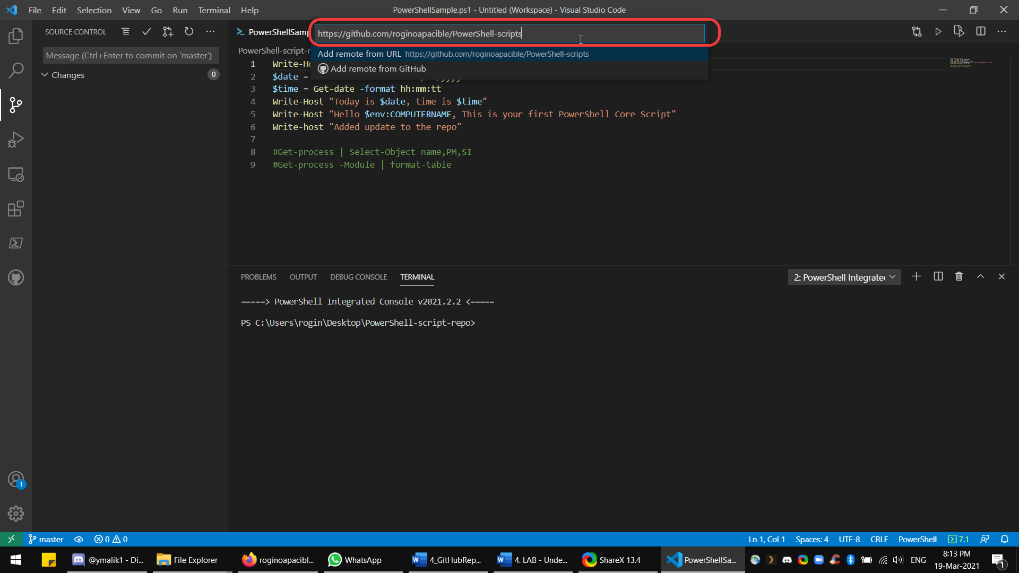
Click yes to update git fetch. | 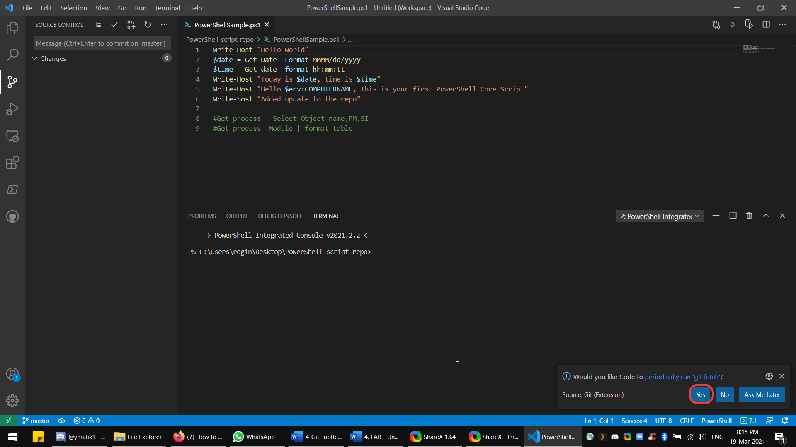
On the task bar, click the publish changes icon. | 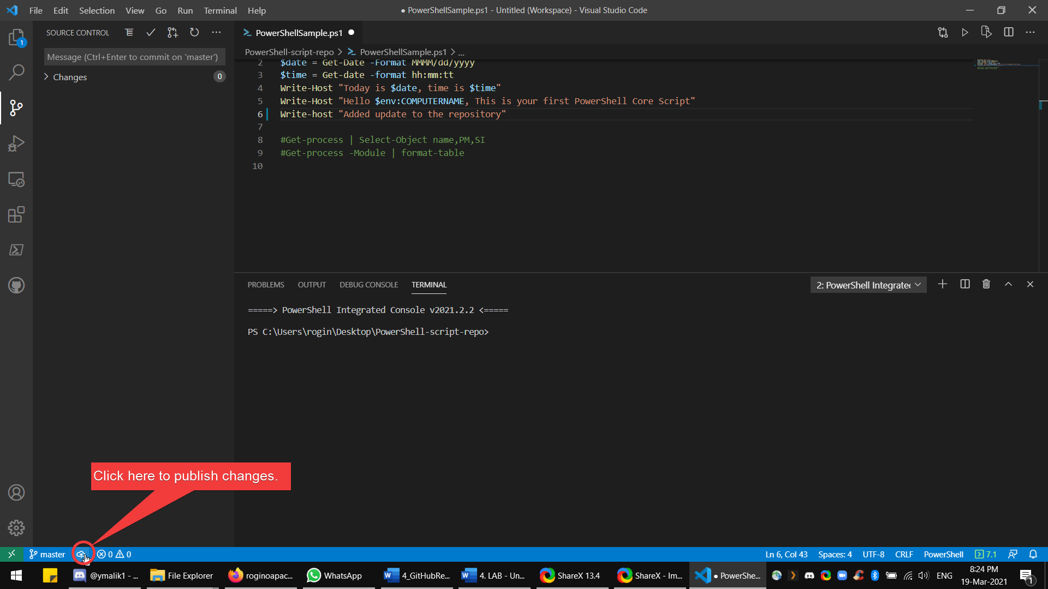
Log-in to GitHub. Using sign in with browser. | 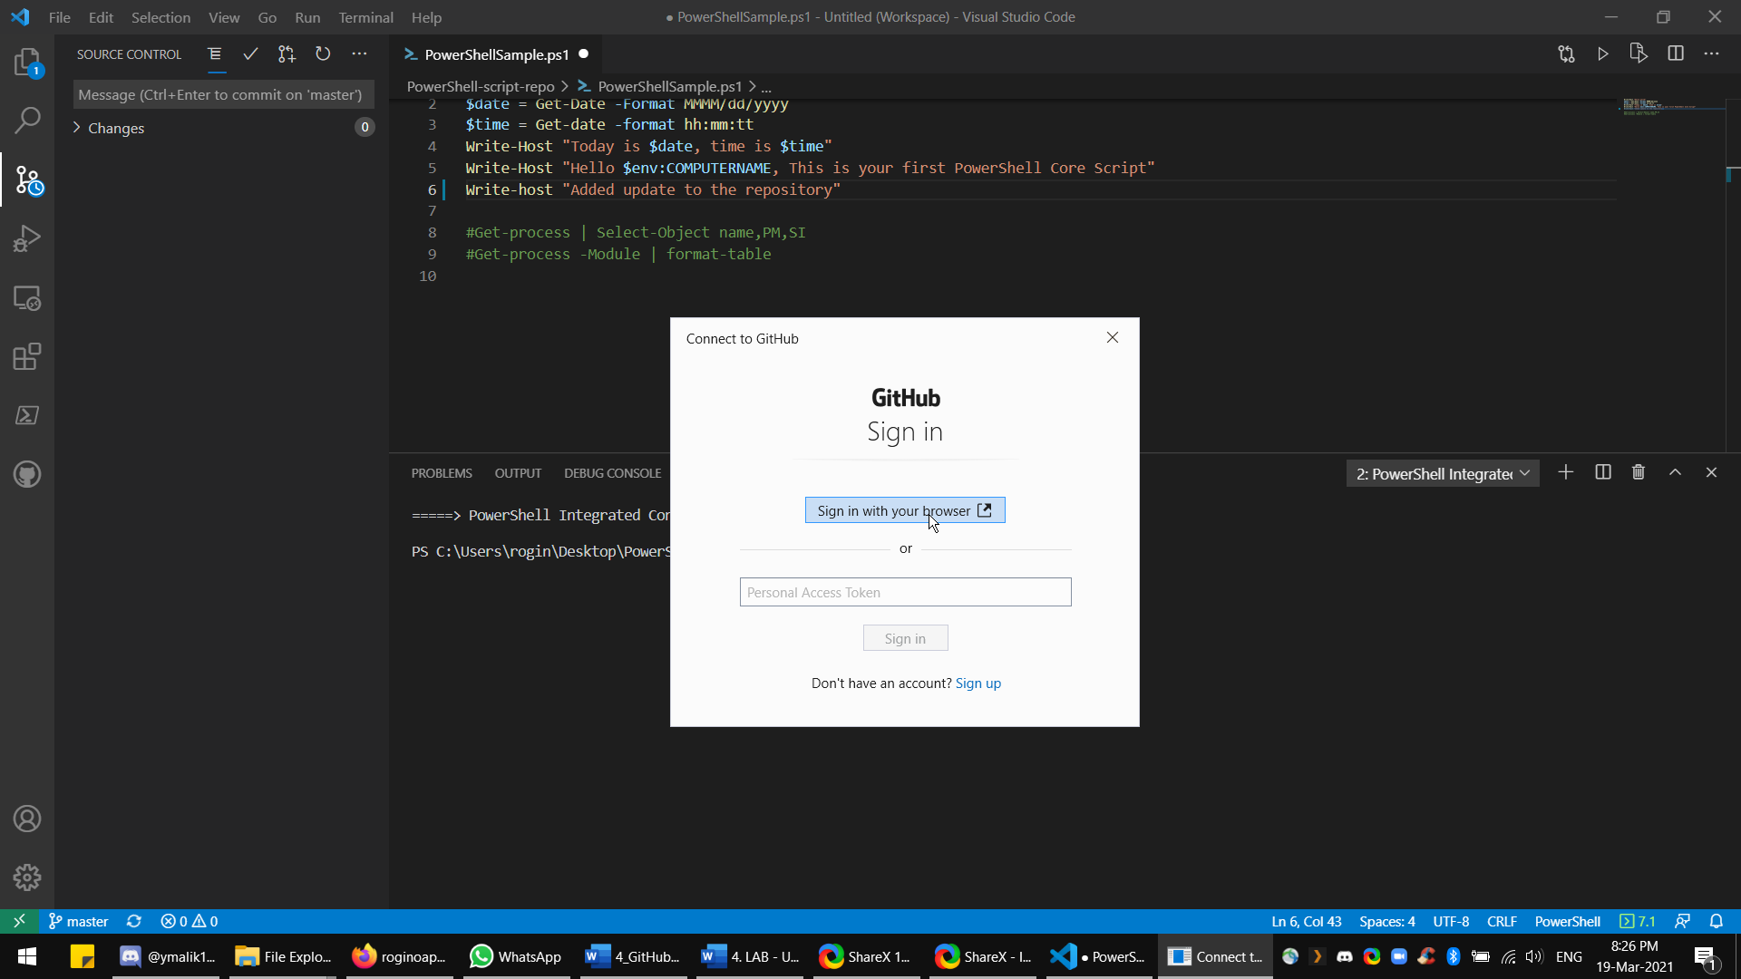
Click create pull request after log.in and authorization in the browser. | 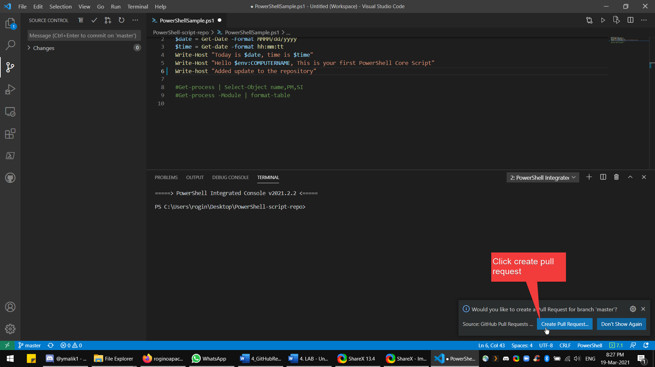
Then go back to github and refresh the repository page.  It will now show the published code to the github repository.  END of LAB. | 